AP Bio 12 Prezi Notes Cells #5: Part 2 Coolio Communicator:

Applications:
Why Cells Communicate, Some Examples:
Quorum Sensing: communication among __________ that triggers _______ response once particular population __________ are reached
Vibrio fischeri: A bacterium that lives inside organs in marine animals.
When population density hits a threshold, they begin to produce a light-producing ________. This gives the host animal ________________________.
Model of quorum sensing in V. fischeri. Don't worry about the specifics, focus on the big picture
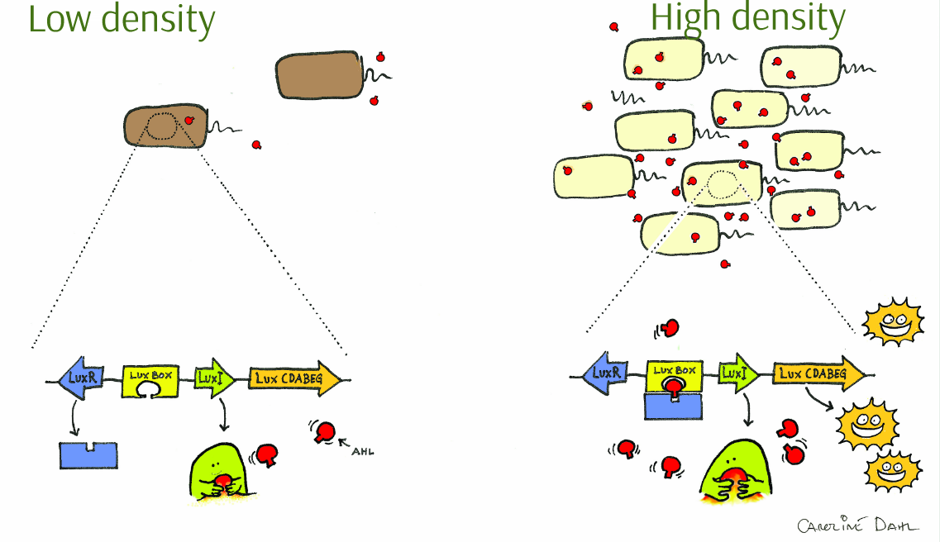

Biofilms: bacterial ________________________that are established and maintained due to elaborate quorum sensing networks

It's All About Signal Reception!
Fruiting Body Formation in Soil Bacteria in response to
_____________ environmental conditions.
How can this kind of behavior evolve?

Yeast Mating:
Mating type in (___________) yeast is genetically determined.
Two mating types (______ and _________). Each makes signaling molecules that the other receives.
The reception of a mating factor leads to the production of a mating "_____________"
Fusion of shmoo's = ___________ yeast cell.
_________________ soon ensues

Graphic Yeast Sex
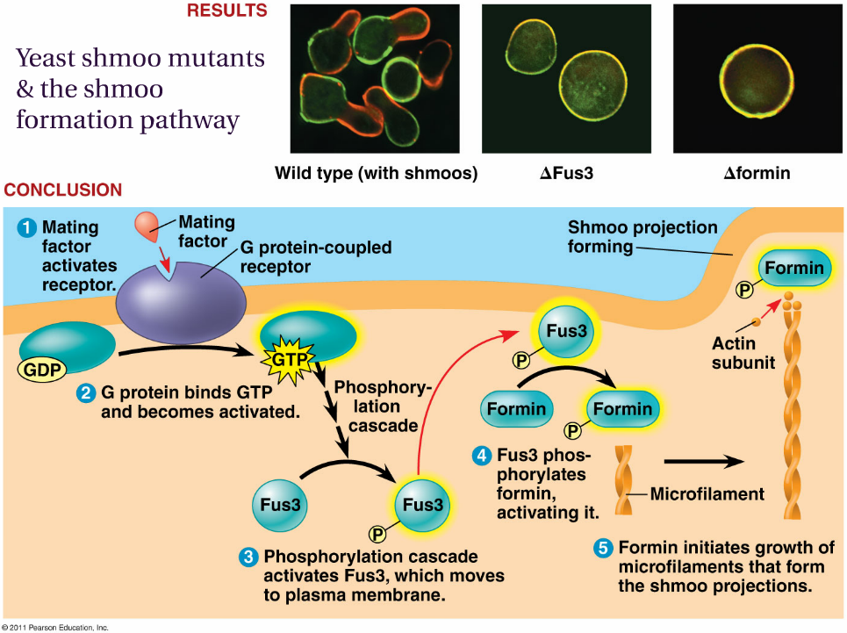

Apoptosis:
Programmed _____________ ______________ is programed because of the ____________ pathway that it is programmed to.

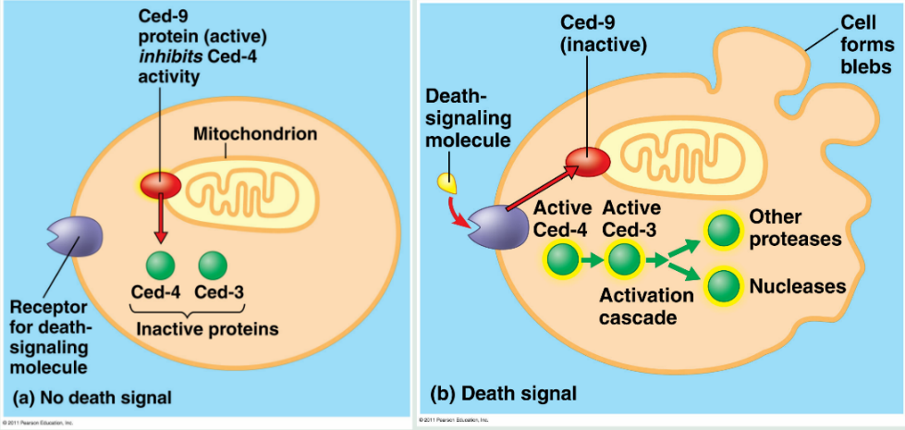

Notice that death proteins are present in an _______________ form prior to signal reception (Why?)

Make Sure You Can:
- Explain why and how cells communicate with the environment.
- Explain the common features shared among cellular communication processes.
- Compare the purpose of cellular communication in unicellular and multicellular organisms
- Describe the major features of signal transduction pathways in cells.
- Connect cellular signaling pathways to actual examples as discussed in this presentation.
- Discuss the evolutionary/adaptive considerations of cellular signaling pathways.

