AP Bio 12 Prezi Notes: Cells #3 Cellular Superstar:

Big Questions:
What does the internal structure of a cell look like?
How do cells separate themselves from their environments?
How do cells communicate with the environment?
How do cells communicate with other cells?
If you recall... The Life of the Cell
All cells must do the following things to stay alive:
- Process ___________: Molecules need to be acquired, synthesized and digested
- Process __________: In order to process matter, energy must be provided. This energy usually comes from one of two places (where?) ___________ & _____________
- Process ____________: The instructions that enable the cell to process matter and energy must be interpreted by the cellular system. Signals from the environment must also be interpreted.
Many cells will also do the following:
_____________: The information that runs the cell must be passed on to new
generations of cells.
_____________: Cells respond to/direct other cells.
Cells have ____________ to do all of these things!
Inside the Cell:
The Cytoskeleton
Structure: A network of structural proteins that extends throughout the cytoplasm.
Functions: -
-
-
-
-
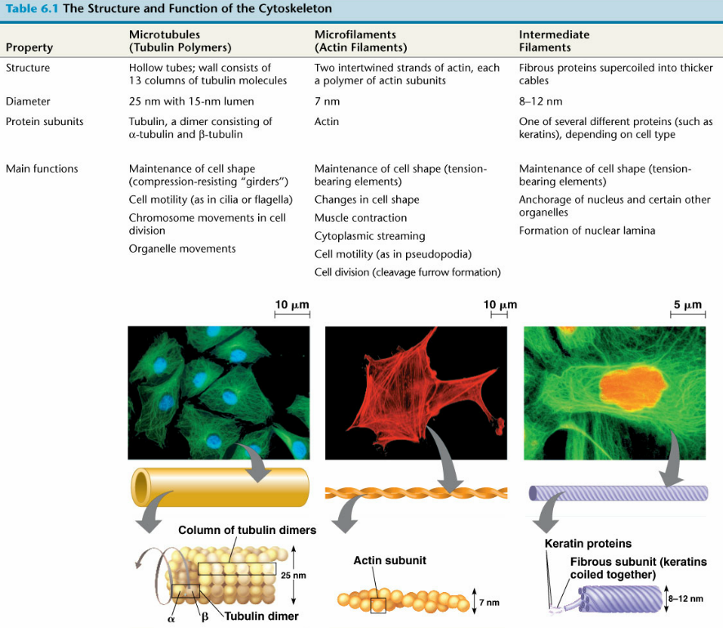

Cilia & Flagella
Structure: Motility related extensions of
cytoskeletal proteins
Function:
Centrosome
Structure: Animal-like cell only microtubule-organizing center
Function:
At The Boundary
The Cell Membrane
Structure: The "Fluid Mosaic Model": A phospholipid bi-layer with associated proteins
Functions: -
-
-
Membrane Phospholipids
Structure: - Lipids with a phosphate attached to glycerol in place of a fatty acid tail.
- Polar (hydrophilic) phosphate "head", nonpolar (hydrophobic) fatty acid tails. This type of polar/non-polar molecule is called "amphipathic"
- Spontaneously organizes in the presence of water to form a bi-layer
- Fluid: phospholipids are constantly moving
Function:

Cholesterol
Structure: a steroid lipid
Function:

Membrane Proteins:
Structure: Various, depending on the role they play:
Integral proteins: penetrate one or both layers of the bi-layer.
Peripheral proteins: associated with the membrane, but don't penetrate the bi-layer.
The polarity of different regions of a membrane protein vary according to the role of that protein.
Functions:
Many and more. Here's brief overview:

Spotlight: Membrane Receptors
Structure: Integral proteins that span the bi-layer with regions ("domains") that extend extra- and intra-cellularly.
Function: Signal Transduction:
Spotlight: Glycoproteins
Structure: Integral proteins that span the bi-layer with short polysaccharide
residues projecting extra-cellularly into the environment
Function: Cell-Cell Recognition:

Glycoproteins are a complication for organ transplants (why?)
Outside The Cell
Cell Wall
Structure: A cross-linked network of structural polysaccharides.
Function:
Cellulose:
Chitin:
Peptidoglycan:
No Cell Walls in Animal-like Cells! ...Why?

ECM
Structure: A network of connective proteins and "proteoglycan" molecules outside of the cell membrane of animal cells
Function:
Only animal cells have any major ECM...Why?
Between Cells
Intracellular Junctions:
Structure: Proteins that connect cells to other cells.
Depending on the junction, a channel between cells may exist
Functions:
Open Junctions:
- Plasmodesmata:
- Gap Junctions:

Closed Junctions:
- Desmosomes:
- Tight Junctions:

Make Sure You Can:
Explain why cells need to have internal structural organization and support.
Explain the structure and function of the cytoskeleton.
Compare the components of the cytoskeleton.
Explain the structure and function of the cell membrane.
Describe the roles of phospholipids, cholesterol, and membrane proteins in cell membrane function.
Explain the structure and function of the cell wall.
Compare the structures of plant-like, fungal, and bacterial cell walls.
Explain the structure and function of the extracellular matrix.
Compare the structure and function of different types of intercellular junctions.

