AP Bio 12 Prezi Notes: Cells #4

Big Questions
How does the cell control what is transported at the cell membrane?
Why is transport of materials between the cell and its environment necessary for life?
How does the environment influence living systems?
How do cells exist within the confines of the Laws of Thermodynamics?

All thing being equal: things spread out!
* This is a consequence of the second law of thermodynamics, which says that the entropy of a system will increase unless energy is added to that system.
Locally energy is added in to living systems.
Globally, no energy is added to the net total energy of the Universe.
A "Messy Room" on 2 different scales

Passive Transport:
Movement of material from [High] to [Low]
No energy required
Diffusion:
The passive transport of molecules across a semi-permeable membrane
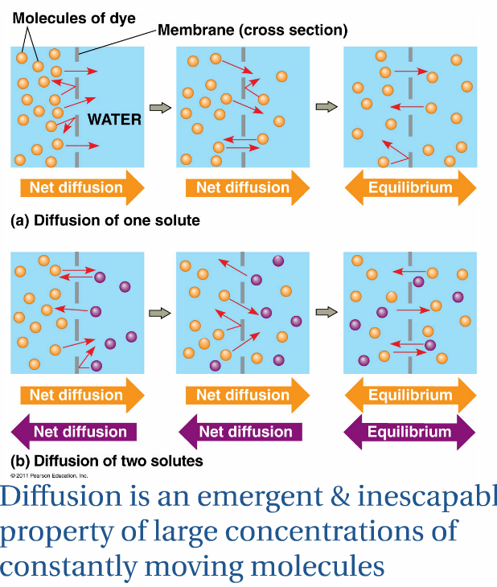
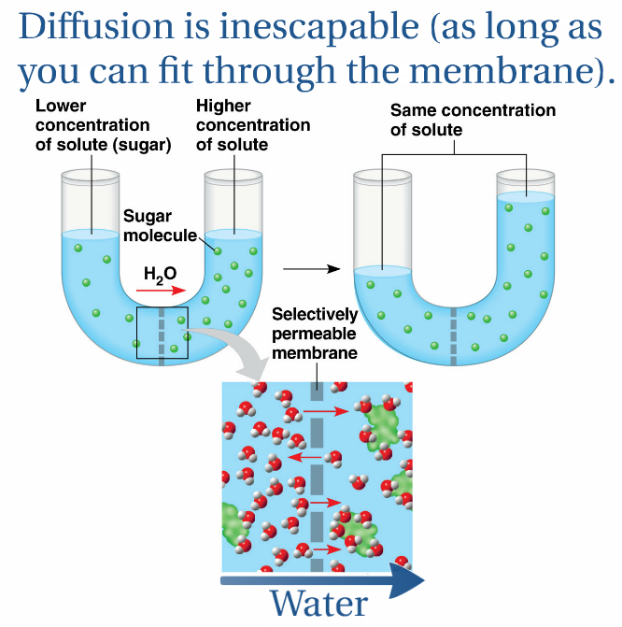
Osmosis:
The Diffusion of water (opposite direction to solute)

Chemistry must be Considered
What can diffuse through the bi-layer?
What does all the other stuff do?
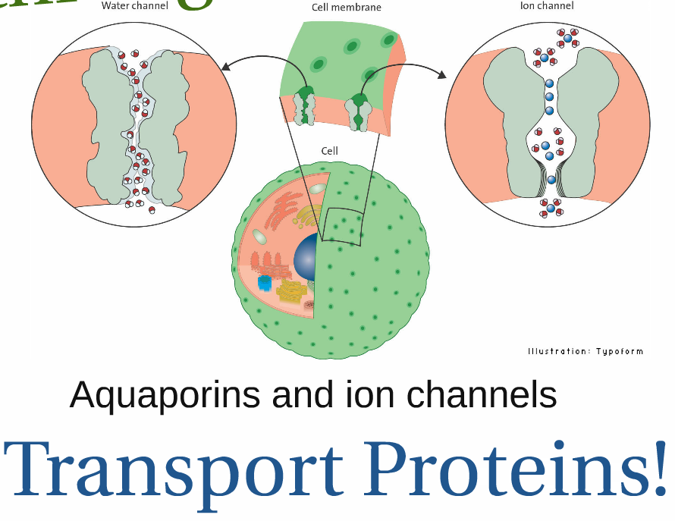
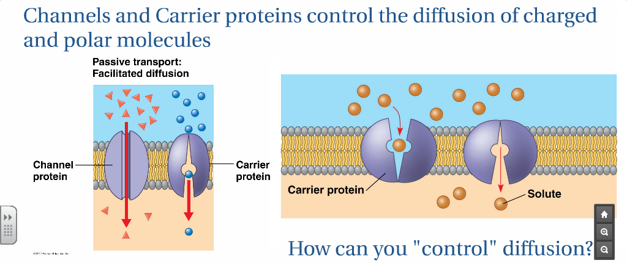

Active Transport:
Movement of material from [Low] to [High]
Energy is required
Must use a protein! Why?
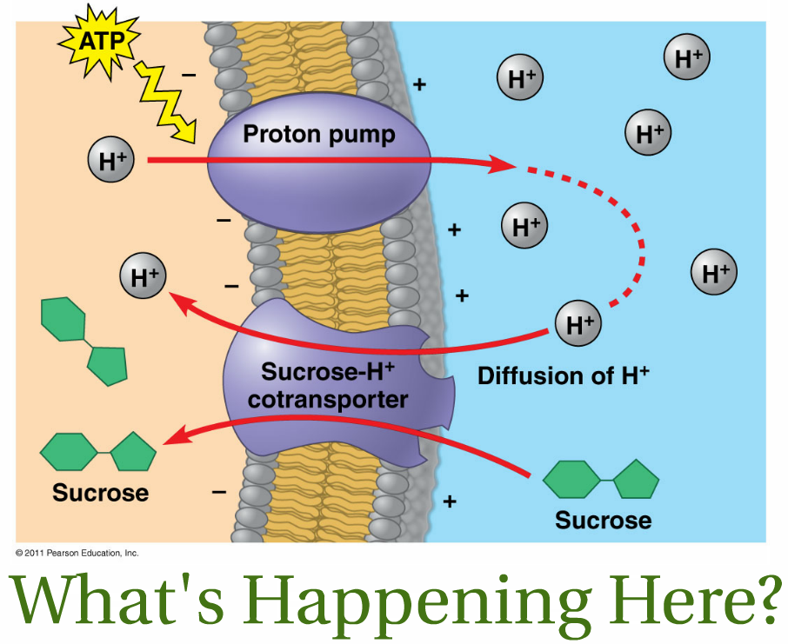
ATP Fills The Energy Requirement
Phosphorylation Triggers a Conformational Change!

Tonicity is important!
Tonicity is a relative measure of solution concentration
The tonicity of a cell's environment has serious consequences for the cell

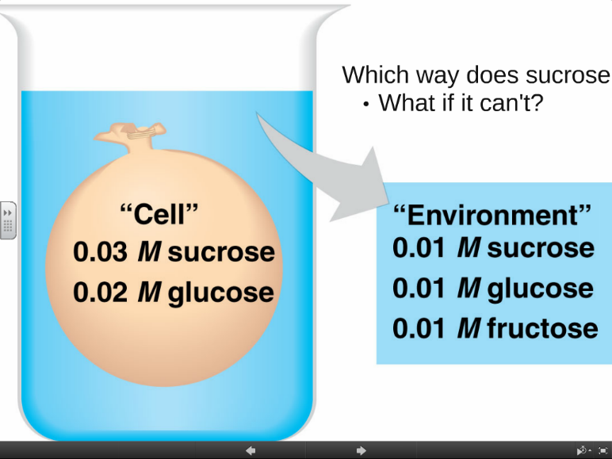
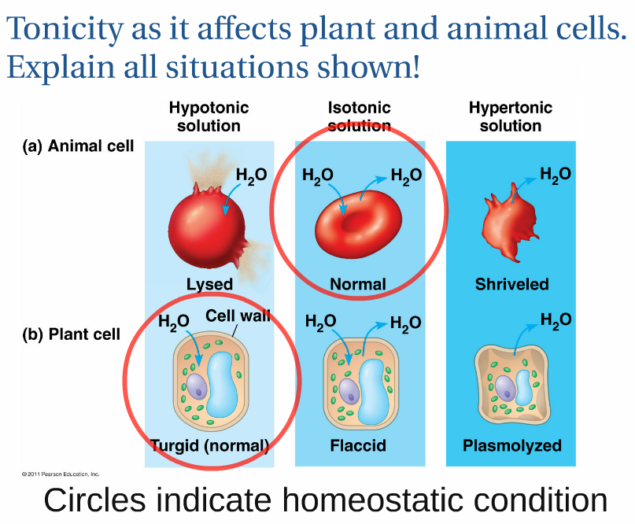

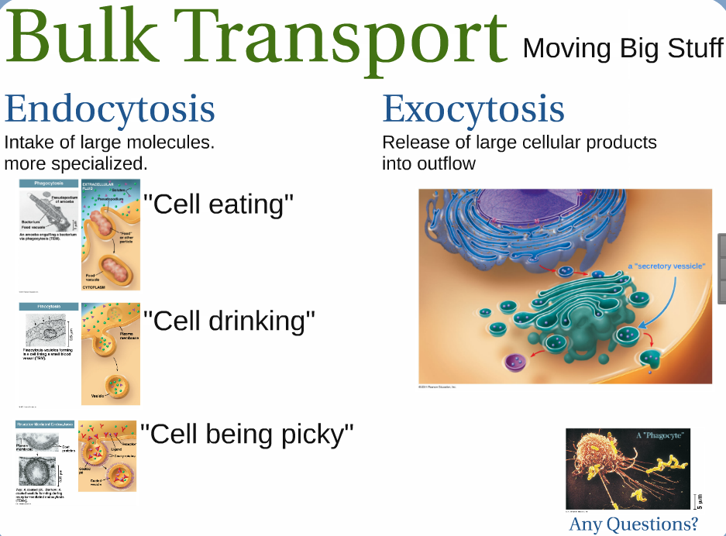
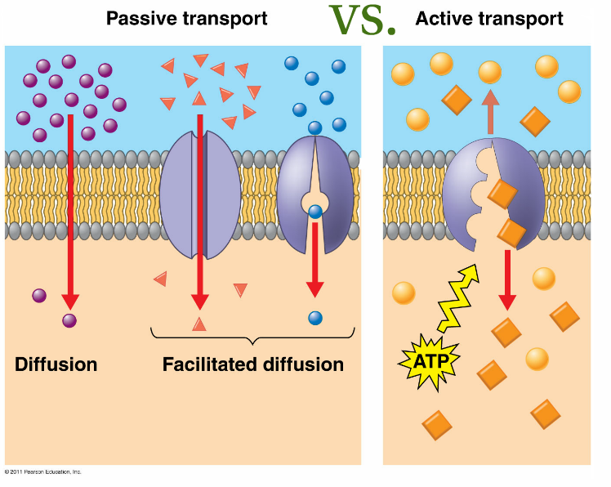

Make Sure You Can
Explain how the consequences of the second law of thermodynamics allow diffusion to occur in the universe without an input of energy.
Compare passive and active transport.
Compare facilitated and simple diffusion.
Compare diffusion of a solute with osmosis of water.
Determine the tonicity relationships when given the concentrations of solutes of multiple solutions.
Predict the movement of specific molecules when given information about their relative concentrations and the characteristics of a given semi-permeable membrane.
Explain why animals and plants have evolved adaptations to survive in solutions of different toncities.
Predict the effect of altering tonicity on a plant or animal cell.
Compare exocytosis and endocytosis.
Explain the purposes and processes of the different modes of endocytosis employed by the cell.

