AP Bio 12 Prezi Notes: Cells #5 (Part1) Signaling Star:

Big Questions:
Why do cells communicate?
What does cellular communication look like?
How is cellular communication utilized in unicellular and multicellular life?

Theory: How Cells Communicate Signal Transduction
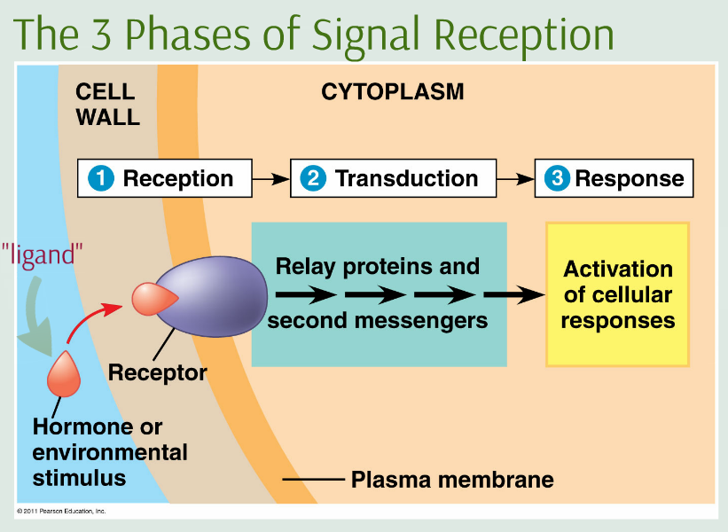

How Signals Are Sent
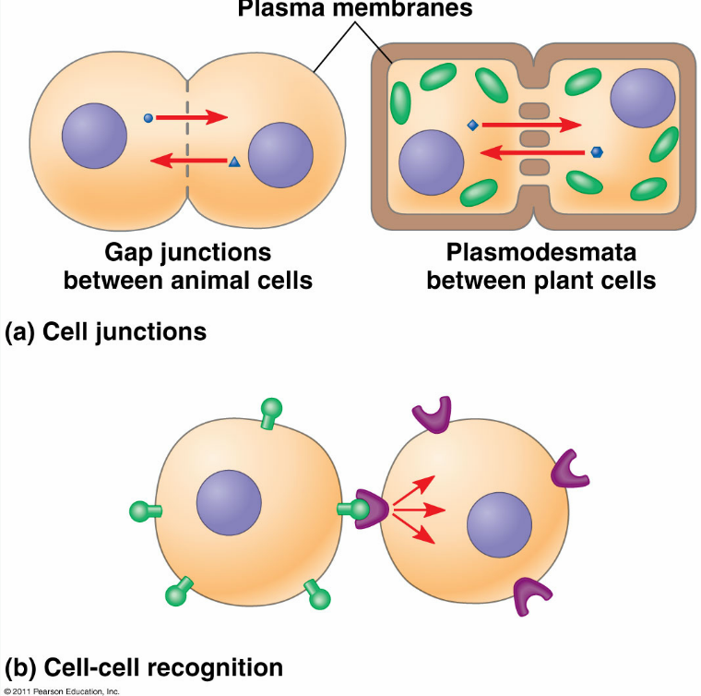
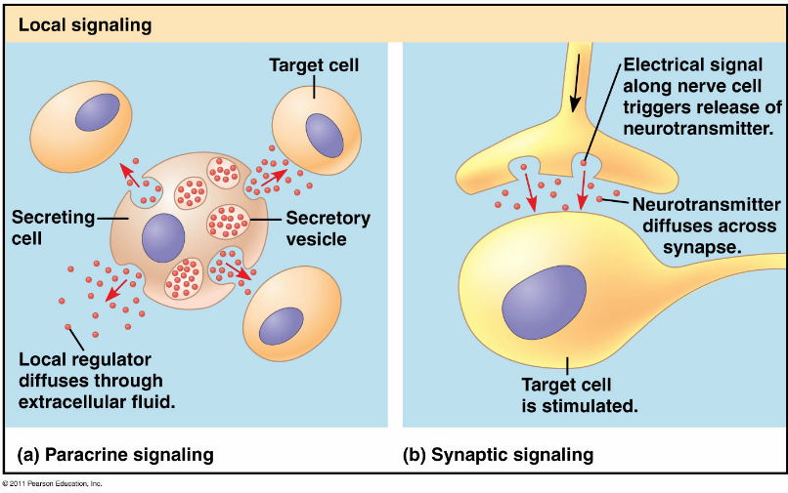

Long Distance Signals
The Nervous and endocrine systems handle these things in animals.
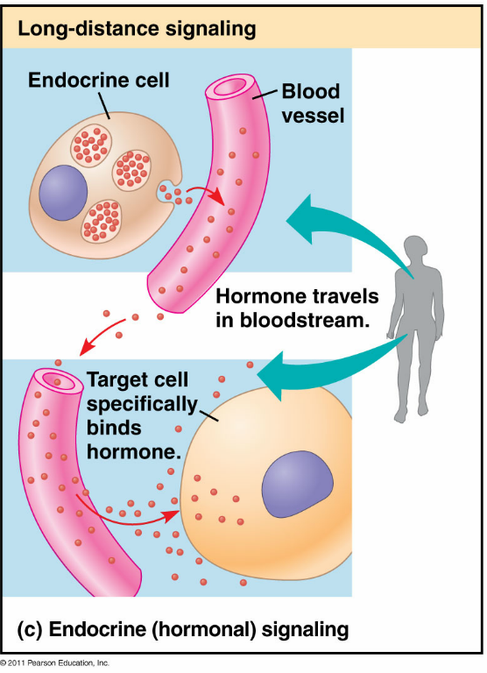

Other Signals
Pretty much any chemical or energy source could serve as a biological signal...though most are biologically created molecules

How Signals Are Received
Different ______________ Different __________ Different ____________
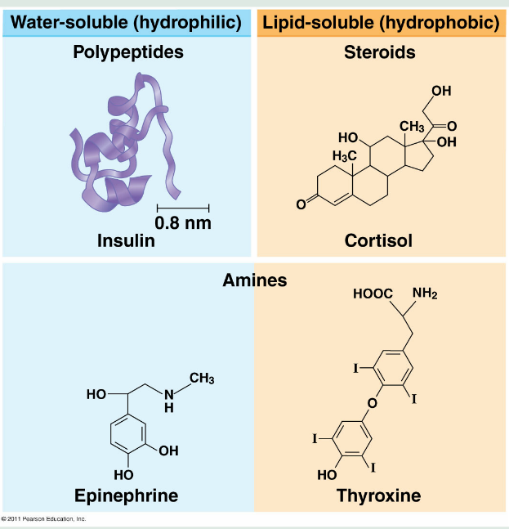

Signaling Pathways
Widely conserved among all domains, why?

G-Protein Linked Reception

Tyrosine Kinases

Kinase:

Tyrosine kinases:

Remain active as long as ligand is attached

Ligand gated ion channels

Second Messengers
- Cyclic AMP:

- Calcium ions:

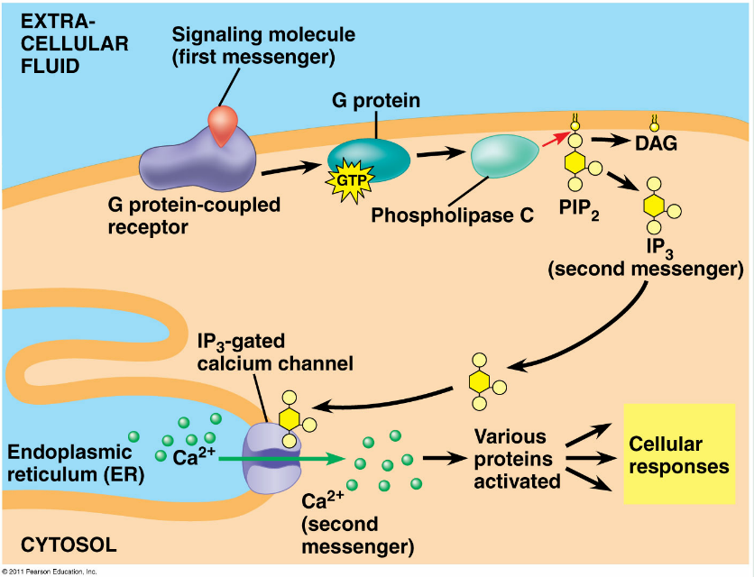

Epinephrine:
- Aka "Adrenaline"
- A common hormone in vertebrates.
- Involved in short term stress ("fight or flight") response.
- Is a polar amine ligand
- Epinephrine signal transduction is mediated by G-Protein linked receptors.
- It has multiple effects, but one response is the inhibition of glycogen synthesis
and the acceleration of glycogen breakdown (why?)

The ligand isn't important. The response is!

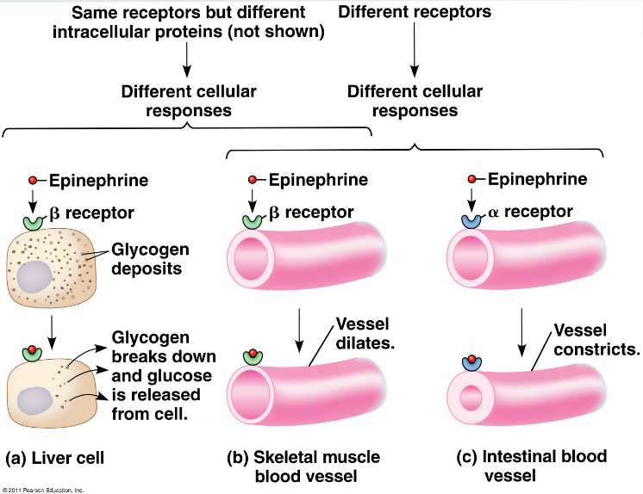

Amplification: more for less

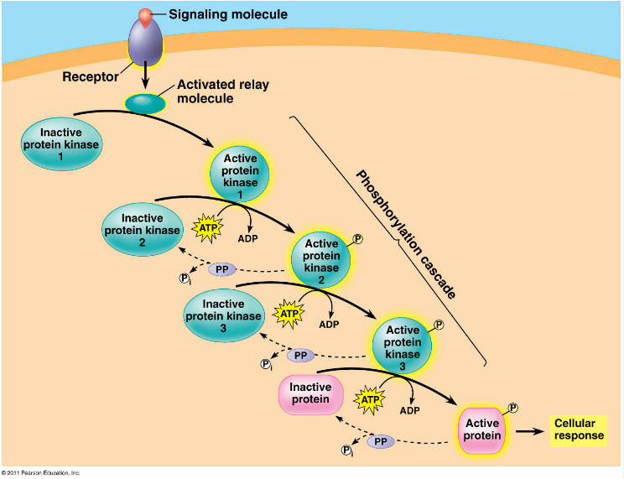
What kind of feedback?

Complication:
A "Branching" Network

