Unit 2 – Cellular Packet

Brilliant Biologist: ________________________
Deadline: ____________________________________________

To Do Checklist:

1. Reading Guides Chapter 6, 7 and 11 (pages 1-15) ______
2. Bozeman Biology Videos (page 16) ______

3. Prezis ______

AP Bio- Cells 1: Intro & Endomembrane System on Prezi

AP Bio- Cells 2: Matter & Energy Processing. on Prezi

AP Bio- Cells 3: Structure & Support on Prezi

AP Bio- Cells 4: Transport on Prezi

AP Bio- Cells 5: Communication on Prezi
4. Labs/Activities _____ a) Microscopy and Cells (page 17-19)
b) Build a Cell Membrane – teacher will provide copy
c) Diffusion and Osmosis Laboratory Investigations (pg 20-25)
c) Life Boat (pg 26)
5. Vocab (pg 27-29) ______
6. Review – Cell Organelle Table and Cell Diagram (pg 30-31) ______

7. Student Objectives (pg 32-37) ______
Chapter 6 Guided Reading Assignment

- What is resolving power and why is it important in biology?
- How does an electron microscope work and what is the difference between a scanning and transmission electron microscope?
- Describe the process and purpose of cell fractionation.
- Label the prokaryotic cell below – list structure and function.
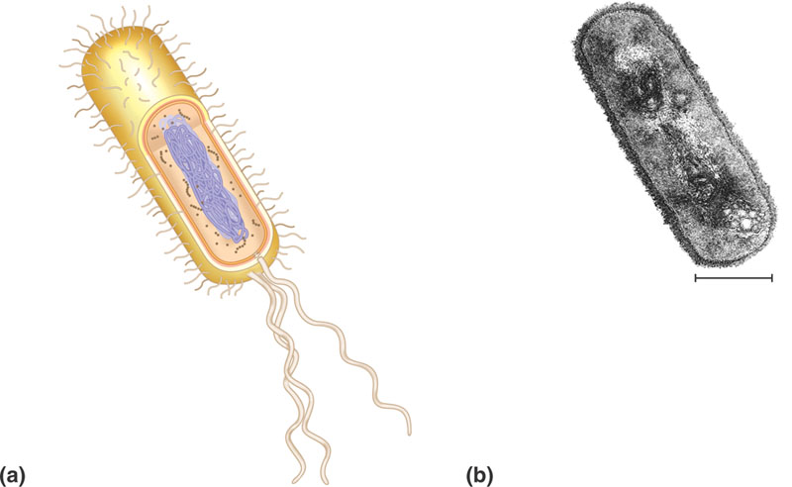
- Why is surface area to volume such an important concept as it applies to the size of a cell?

- For each of the structures below – note the specific structure and the function of the organelle or part of the organelle. The important concept is to note how the specific structure allows for the specific function to be accomplished.
  - Nucleus
    - Nuclear envelope
    - Nuclear lamina
    - Chromosomes
    - Chromatin
    - Nucleolus
  - Ribosomes
  - Endoplasmic reticulum
    - Smooth ER
    - Rough ER
  - Golgi Apparatus
  - Lysosomes
  - Vacuoles
    - Food
    - Contractile
    - Central w/tonoplast
  - Endomembrane system – overall
  - Mitochondria
    - Mitochondrial matrix
    - Cristae
  - Plastids
    - Amyloplast
    - Chromoplast
    - Chloroplast
      - thylakoids
      - stroma
  - peroxisomes
  - cytoskeleton – pay careful attention to the details in this section
    - microtubules
      - centrosomes and centrioles
      - cilia and flagella – include basal body
      - dynein walking
    - microfilaments
      - actin
      - myosin
      - pseudopodia
      - cytoplasmic streaming
    - intermediate filaments
  - Cell walls
    - Primary cell wall
    - Middle lamella
    - Secondary cell wall
  - Extracellular matrix
    - Collagen
    - Proteoglycans
    - Fibronectin
    - Integrins
  - What are intercellular junctions and why are they important?
  - Contrast plasmodesmata, tight junctions, desmosomes, and gap junctions.

Chapter 7 Guided Reading

- What does selective permeability mean and why is that important to cells?
- What is an amphipathic molecule?
- What were the ideas concerning the plasma membrane models below:
  - Gorter and Grendel
  - Davson and Danielli
  - Singer and Nicolson
- Describe the freeze fracture technique and why is it useful in cell biology.
- How is the fluidity of cell membrane’s maintained?
- Label the diagram below – for each structure – briefly list it’s function:
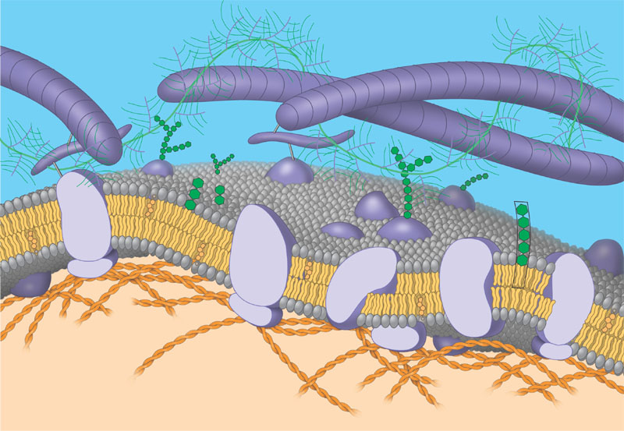
- List the six broad functions of membrane proteins.
- How do glycolipids and glycoproteins help in cell to cell recognition?
- Why is membrane sidedness an important concept in cell biology?
- How has our understanding of membrane permeability changed since the discovery of aquaporins?
- What is diffusion and how does a concentration gradient relate to passive transport?
- Why is free water concentration the “driving” force in osmosis?
- Why is water balance different for cells that have walls as compared to cells without walls?
- Label the diagram below:
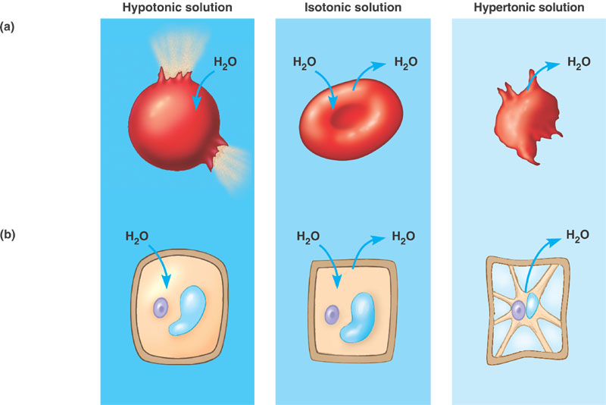
- What is the relationship between ion channels, gated channels and facilitated diffusion – write 1 -2 sentences using those terms correctly.
- How is ATP specifically used in active transport?
- Define and contrast the following terms: membrane potential, electrochemical gradient, electrogenic pump and proton pump.
- What is cotransport and why is an advantage in living systems?
- What is a ligand?
- Contrast the following terms: phagocytosis, pinocytosis and receptor-mediated endocytosis.

Chapter 11 Guided Reading Assignment

This chapter is often considered difficult as you have not covered it in your introductory biology course. Plan on reading this chapter at least twice and go slowly. I would suggest that you read the key concepts in bold first and then for each concept, look at the headings, then the figures and then read.

- What is a signal transduction pathway?
- How do yeast cells communicate while mating?
- How do intercellular connections function in cell to cell communication?
- Explain the two types of local signaling:
  - Paracrine signaling
  - Synaptic signaling
- How are long distance signals sent?
- Explain Sutherland’s investigations with epinephrine and the inferences that were derived from this work.
- Define the three stages of cell communication:
  - Reception
  - Transduction
  - Response
- What is a ligand?
- What is special about intracellular receptors – hint think of the structure of the cell membrane and how this relates?
- Label the diagram below of a steroid interacting with an intracellular receptor.
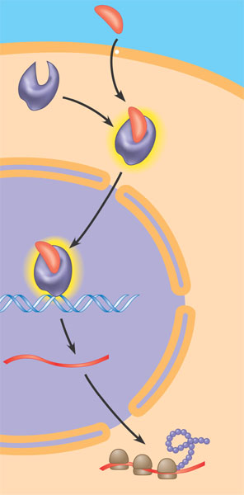
- Where would you expect most water soluble messengers to bind and why?
- What is a G-protein-linked receptor?
- The G-protein-linked receptor is located ___________________. When GDP is attached to the G protein the messenger is considered _______. GTP replaces GDP and now the messenger is considered _______. The G protein carrying the GTP leaves the receptor and _______ and enzyme which causes a cellular response. All of this is brought on by a _______ ________ attaching to the G-protein-linked receptor and will shut down quickly when the ___________ ____________ is no longer there.
- What is a kinase?
- A tyrosine kinase receptor is different from a G-protein linked receptor in that it can trigger ______ _______ ______ pathway at the same time. When both ____________ ____________ are in their receptor sites, the molecules form a dimer – two molecules joined together. ATP is converted to ADP and the __________ gets attached to the tyrosine molecules. The addition of the _____________ causes a cascade of cellular responses.
- Ligand gated means controlled by the _______ or signal molecule. If the door is closed, certain ____ are blocked from entering the cell. When the ___________ or signal molecule is attached, the door is open for certain _____ to enter the cell. These types of receptors are important in the __________ _____________.
- What does conformation mean?
- What is a signal transduction pathway?
- Phosphorylation cascades are similar to a row of dominoes falling down, instead of one domino knocking down the next, a phosphate being added activates the message. In this way, a series of different _______ are each ___________ one after another. Inactive protein kinase 1 gets a _________ added and now it is _________ protein kinase 1. Active protein kinase 1 transfers a _______ and now inactive protein kinase 2 is now ________. This continues until the desired __________ is activated to cause a cellular response.
- What are protein phosphatases and why are they so important?
- What are second messengers and what are two characteristics of a second messenger?
- What did Sutherland find in his experiments with regard to cyclic AMP and why is this important?
- What is adenylyl cyclase?
- Complete the diagram below of cAMP as second messenger:
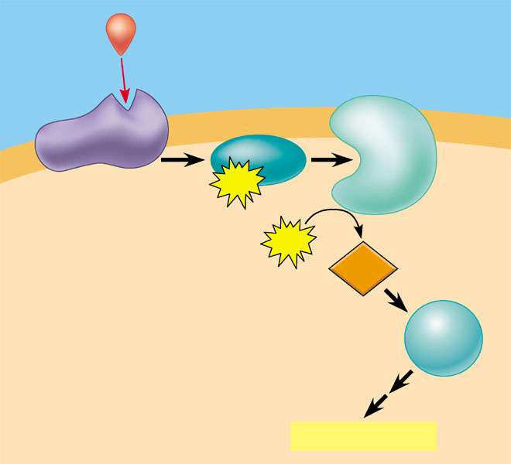
- How does cholera connect with the concepts of cell to cell communication?
- How and why are the calcium concentrations kept different and separate comparing the endoplasmic reticulum, mitochondria and cytoplasm?
- Label the diagram below showing calcium and IP₃ in a cell.
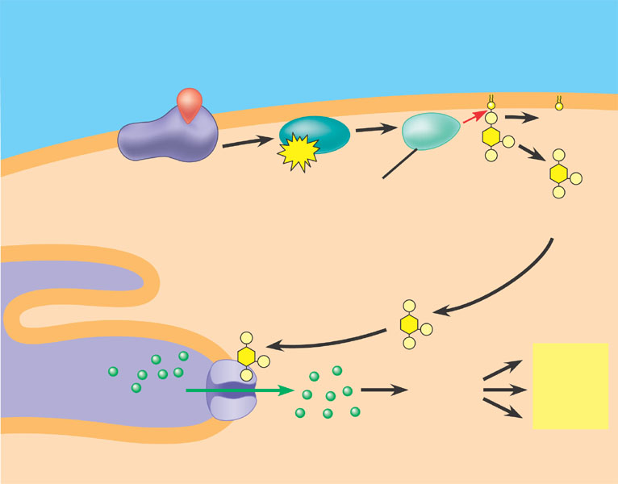
- How is signal amplification accomplished in the cell?
- How is specificity accomplished in cell signaling?
- What is a scaffolding protein and why is it important?
- How is termination of a signal accomplished and why is it so important that termination be accomplished?

Bozeman Biology Videos

Chapter 6

Cellular Variation (Essentials #52)
Why are cells small?
Cellular Organelles (Essentials #43)
Compartmentalism-Specialization (AP Essentials #17)
Chapter 7
Cellular Membranes (AP Essentials #15)
The Cell Membrane
Transport across membranes (AP Essentials #16)
Osmosis Lab Walkthrough
Diffusion Demo
Osmoregulation

Chapter 11

Signal Transmision and Gene Expression
(Biology Essentials #32)
Evolutionary Significance of Cell Communication (AP Essentials #36)
Cell Communication (AP Essentials #37)
Signal Transduction (AP Essentials #38)
Effects of Changes in Signal Transduction(Essentials #39)

Microscopy Lab

Procedure:
- Review proper microscopy technique:
  - List five parts of the microscope and describe their function:

  - List two rules you should always follow when using our precious, precious microscopes:

- Use the microscope to look at 6 different slides. Make sure you see at least one bacterial slide, one animal slide and one plant slide. For each one, draw what you see, note the name of the slide and the total magnification you are viewing it at.

Slide Name: Slide Name:

Total Magnification: Total Magnification:

Slide Name: Slide Name:

Total Magnification: Total Magnification:

Slide Name: Slide Name:

Total Magnification: Total Magnification:

Diffusion and Osmosis Laboratory Investigations

Part 1- Testing for Diffusion: A Guided Activity
Introduction:
In this exercise you will measure diffusion of small molecules through dialysis tubing, an example of a semi- permeable membrane. The movement of a solute through a semi permeable membrane is called dialysis (as well as diffusion). The size of the minute pores in the dialysis tubing determines which substance can pass through the membrane. A solution of glucose and starch will be placed inside a bag of dialysis tubing. Distilled water will be placed in a beaker, outside the dialysis bag. After 30 minutes have passed, the solution inside the dialysis tubing and the solution in the beaker will be tested for glucose and starch. The presence of glucose will be tested with glucose test strips. The presence of starch will be tested with Lugol's solution (iodine-potassium -iodide).
Procedure:
1. Obtain a 30 cm piece of 2.5-cm dialysis tubing that has been soaking in water. Tie off one end of the tubing to form a bag. To open the other end of the bag, rub the end between your fingers until the edges separate.
2. Place 15 mL of the 15% glucose/1% starch solution in the bag. Tie off the other end of the bag, leaving sufficient space for the expansion of the bag's contents. Record the color of the solution in Table 1.1.
3. Test the 15% glucose / 1% starch solution in the bag for the presence of glucoseusing glucose test strips. Record the results in Table1.1.
4. Fill a 250 mL beaker or cup 2/3 full with distilled water. Add approximately 4 mL (4 drops) of Lugol's solution to the distilled water and record the color in Table 1.1. Test the solution for glucose and record the results in Table 1.1.
5. Immerse the dialysis bag in the beaker of water plus Lugol’s.
6. Allow your set up to stand for approximately 30 minutes or until you see a distinct color change in the bag or the beaker. Record the final color of the solution in the bag and of the solution in the beaker in Table 1.1. 7. Test the liquid in the beaker and in the bag for the presence of glucose. Record the results in Table 1.1.

Table 1.1 : Dialysis Tubing Changes
 | Initial Contents | Initial Solution Color | Final Solution Color | Initial Presence of Glucose | Final Presence of Glucose
Bag | 15% glucose/ 1% starch solution
Beaker | H₂O + IKI

Analysis of Results:
Answer all of these questions in their own section of your lab report. Include your table of results.
1. Which substance(s) are entering the bag and which are leaving the bag? What experimental evidence supports your answer?
2. Explain the results you obtained. Include the concentration differences and membrane pore size in your discussion.
3. Quantitative data uses numbers to measure observed changes. How could this experiment be modified so that quantitative data could be collected to show that water diffused into the dialysis bag?
4. Based on your observations, rank the following by relative size, beginning with the smallest: glucose molecules, water molecules, IKI molecules, membrane pores, starch molecules.
5. What results would you expect if the experiment started with glucose and IKI solution inside the bag and only starch and water outside? Why?

Part 2: Osmosis Investigation: A Guided Activity
Introduction:
In this exercise, you will use dialysis tubing to investigate the relationship between solute concentration and the movement of water through a semi-permeable membrane by the process of osmosis. When two solutions have the same concentration of solutes, they are said to be isotonic to each other. If the two solutions are separated by a semi permeable membrane, water will move between the two solutions, but there will be no net change in the amount of water in either solution. If two solutions differ in the concentration of solutes that each has, the one with more solute is hypertonic to the one with the less solute. The solution that has less solute is hypotonic to the one with more solute. These terms can only be used to compare solutions.
Procedure:
1. Obtain a 30 cm strip of pre-soaked dialysis tubing
2. Pour approximately 25 mL of the following solutions into each bag (Note: Your instructor may give you a subset of the solutions to be responsible for).
- Distilled Water | • 0.6 M sucrose
• 0.2 M sucrose | • 0.8 M sucrose
• 0.4 M sucrose | • 1.0 M sucrose
3. Remove most of the air from the bags by drawing the dialysis bag between two fingers. Tie off the other end of the bag, leaving sufficient space for expansion.
4. Rinse each bag gently with distilled water to remove any sucrose spilled during filling.
5. Carefully blot the outside of each bag and record the initial mass of each bag in Table 1.2.
6. Fill one 250 mL beakers 2/3 full with distilled water for each tube you are responsible for.
7. Immerse each bag in one of the beakers of distilled water and label the beaker to indicate the molarity of the solution in the dialysis bag. Be sure to completely submerge each bag.
8. Let each bag stand for 30 minutes, remove the bags from the water, blot and determine their mass
9. Record your group’s results in Table 1.2. Obtain data from the other lab groups
10. Graph the results for both your individual data and class average on the following graph.

Table 1.2 Dialysis Tubing Results
Solution | Initial Mass | Final Mass | Mass Difference | % Change in mass
Distilled Water
0.2 M Sucrose
0.4 M Sucrose
0.6 M Sucrose
0.8 M Sucrose
1.0 M Sucrose

Formula for % Change in Mass:
final mass - initial massinitial mass X100
Analysis of Results:
Answer all of these questions in their own section of your lab report. Include the table of class results, and a graph of the data showing the relationship between % change in mass of the dialysis tubing and tonicity of the solution.
1. Explain the relationship between the change in mass and the molarity of sucrose within the dialysis bag.
2. Predict what would happen to the mass of each bag in this experiment if all the bags were placed in a 0.4 M sucrose solution instead of distilled water. Explain your response.
3. Why did you calculate the percent change in mass rather than using the change in mass?
4. A dialysis bag is filled with distilled water and then placed in a sucrose solution. The bag’s initial mass is 20 g. and its final mass is 18 g. Calculate the percent change of mass, showing your calculations in the space below.
5. The sucrose solution in the beaker would have been ___________________ to the distilled water in the
bag.
Part 3: Determining the Water Potential of Potato Cells- A Guided Activity

Introduction:
Water potential is defined as the tendency of water to diffuse from one region to another. Water potential is also a numerical value that varies according to temperature, and a series of other physical conditions. Water will move from an area of higher water potential to an area of lower water potential. Water potential values are all compared to pure water (which is assigned a water potential of 0). Water potential is signified with the greek letter psi (ψ). In total, water potential is the sum of several different factors, which can each contribute to water potential. These include factors like pressure (ψ_{p}), and solute concentration (ψ_{s}). In this activity you will determine the water potential of potato cells at room temperature and ambient pressure by placing cores of potato tissue in sucrose solutions of different concentrations and measuring the net movement of water in each case. To do this, we will only need to determine the Solute Potential of the potato cells, since that will be the only differential condition in our experiment.
Water potential is typically given in units of pressure. The units of water potential depend on the pressure units you use in the equation. In this experiment our units will be bars (i.e. milimeters of mercury in a barometer).
Procedure:
1. Cut 5 potato cylinders. Cut each cylinder to a length of 3 cm
2. Determine mass of all 5 potato cylinders together.
3. Place cylinders in the assigned solution:
- Distilled Water | • 0.6 M sucrose
• 0.2 M sucrose | • 0.8 M sucrose
• 0.4 M sucrose | • 1.0 M sucrose

4. Let stand overnight.
5. Record temperature, remove cylinders, and determine mass of all 5 cylinders.
6. Determine percent change in mass.
7. Record all data in Table 1.3 Graph class results for the relationship between molarity of the sucrose solution and the % change in mass of the potato cores.
8. Determine the molarity of the sucrose solution in which the mass of the potato cores does not change. Determine this value from the graph...draw a line of best fit: The point at which this line crosses the x- axis represents the molar concentration of sucrose with a water potential that is equal to the potato tissue water potential. At this concentration there is no net gain or loss of water from the tissue
9. Calculate the osmotic potential (denoted by the greek letter psi sub pi )of this sucrose solution using the following formula:
s= -iCRT

Where:
- i = ionization constant (this is 1 for sucrose because sucrose does not ionize in water)
- C = osmotic constant molar concentration (the isoosmotic point determined from the graph above)
- R = 0.0831 liter * bar/mole * °K
- T = temperature in Kelvin (Kelvin Temperature = Celsius Temperature + 273)
Units of osmotic potential will be bars (This is a measure of pressure)

10. The water potential of the potato cells (discounting the ambient pressure is equal to the osmotic potential of the sucrose solution at equilibrium.
Table 1.3: Potato Osmosis Results
Solution | Temperature | Initial Mass | Final Mass | % Change in mass
Distilled Water
0.2 M Sucrose
0.4 M Sucrose
0.6 M Sucrose
0.8 M Sucrose
1.0 M Sucrose

Analysis of Results:
Answer all of these questions in their own section of your lab report. Include the table of class results, and a graph of the data showing the relationship between % change in mass of the potato cells and tonicity of the solution.
Analysis of Results
1. If the potato is allowed to dehydrate by sitting in the open air, would the water potential of the potato cells become higher or lower? Explain and include specific identification of the variable that in the equation that would be affected.
2. If a plant cell has a lower water potential than its surrounding environment and if pressure is equal to zero, is the cell hypertonic (in terms of solute concentration) or hypotonic to its environment? Explain.
Part 4: Determining the Water Potential of Another Vegetable or Fruit- An Inquiry Activity
Objective:
Using the knowledge that you have gained from the above investigations, work with your group to develop a procedure to determine the water potential of another vegetable or fruit of your choosing.
What To Include In Your Report:
- Your groups procedure
- A table of your individual results
- A graph to show determination of the isoosmotic point of your vegetable/fruit
- A calculation of water potential for your vegetable/fruit
- A table of class data on isoosmotic point and water potential for all vegetables & fruits investigated.
- A discussion of the results of this part of the laboratory, in keeping with normal conclusion expectations.

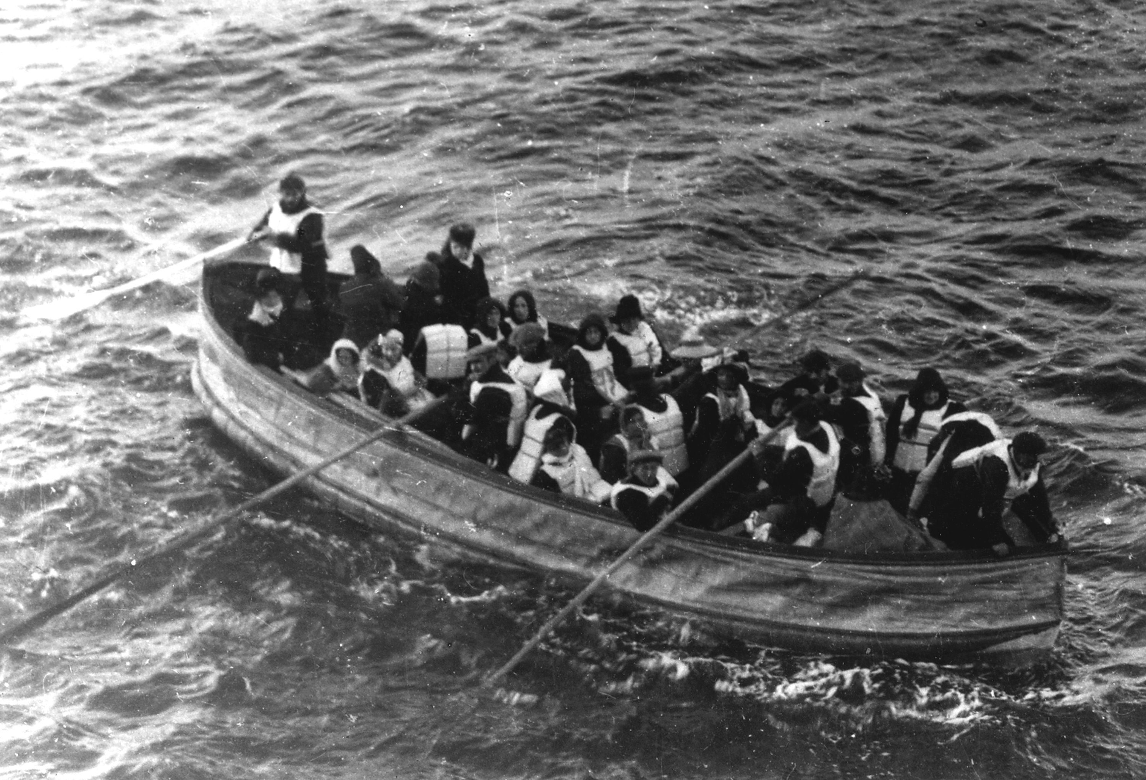
Why am I essential to the cell?
Lifeboat Dilemma!!

A captain and his crew of 3 (not as in the pic above) were in a small boat their ship had sunk down to the bottom depths of the oceans (and no it did not meet Sponge Bob). The captain had discovered that the life boat would not withstand the weight of the crew much longer and so…
The captain has decided to throw someone over (into the shark infested waters) ….will it be you?????
In a group of 4, randomly select numbers to determine who is who.
- Captain Bossy Boots.
- Mike the Mighty Mitochondria (has a bit of an ego issue)
- Frannie Cell Membrane (very flexible and likes to keep everyone all together)
- Rhianna Ribosome (small but feisty and is always on a high protein diet)
Crew members will have to read their "Don't throw me overboard cause I am so…" to the class and the class will decide who to throw overboard.
Make sure it is not you, the sharks are hungry!
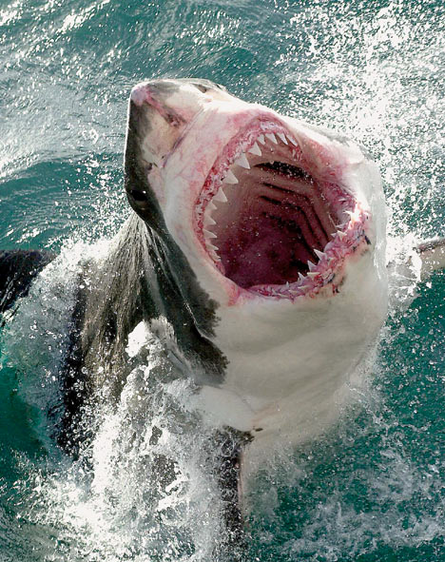

CHAPTER 6 VOCAB- Cell Structure and function
actin  basal body  cell fractionation  cell wall  central vacuole  centriole  centrosome  chloroplast  chromatin  chromosome  cilium  collagen  contractile vacuole  crista  cytoplasm  cytoplasmic streaming  cytoskeleton | cytosol  desmosome  dynein  electron microscope (EM)  endomembrane system  endoplasmic reticulum (ER)  eukaryotic cell  extracellular matrix (ECM)  fibronectin  flagellum  food vacuole  gap junction  glycoprotein  Golgi apparatus  granum  integrin  intermediate filament | light microscope (LM)  lysosome  microfilament  microtubule  middle lamella  mitochondrial matrix  mitochondrion  myosin  nuclear envelope  nuclear lamina  nucleoid  nucleolus  transmission electron microscope (TEM)  transport vesicle  ultracentrifuge
Word Roots
centro- the center; -soma a body (centrosome: material present in the cytoplasm of all eukaryotic cells and important during cell division)
chloro- green (chloroplast: the site of photosynthesis in plants and eukaryotic algae)
cili- hair (cilium: a short, hairlike cellular appendage with a microtubule core)
cyto- cell (cytosol: a semifluid medium in a cell in which organelles are located)
-ell small (organelle: a small, formed body with a specialized function found in the cytoplasm of eukaryotic cells)
endo- inner (endomembrane system: the system of membranes within a cell that includes the nuclear envelope, endoplasmic reticulum, Golgi apparatus, lysosomes, vacuoles, and the plasma membrane)
eu- true (eukaryotic cell: a cell that has a true nucleus)
extra- outside (extracellular matrix: the substance in which animal tissue cells are embedded)
flagell- whip (flagellum: a long, whiplike cellular appendage that moves cells)
glyco- sweet (glycoprotein: a protein covalently bonded to a carbohydrate)
lamin- sheet/layer (nuclear lamina: a netlike array of protein filaments that maintains the shape of the nucleus)
lyso- loosen (lysosome: a membrane-bounded sac of hydrolytic enzymes that a cell uses to digest macromolecules)
micro- small; -tubul a little pipe (microtubule: a hollow rod of tubulin protein in the cytoplasm of almost all eukaryotic cells)
nucle- nucleus; -oid like (nucleoid: the region where the genetic material is concentrated in prokaryotic cells)
phago- to eat; -kytos vessel (phagocytosis: a form of cell eating in which a cell engulfs a smaller organism or food particle)
plasm- molded; -desma a band or bond (plasmodesmata: an open channel in a plant cell wall)
pro- before; -karyo nucleus (prokaryotic cell: a cell that has no nucleus)
pseudo- false; -pod foot (pseudopodium: a cellular extension of amoeboid cells used in moving and feeding)
thylaco- sac or pouch (thylakoid: a series of flattened sacs within chloroplasts)
tono- stretched; -plast molded (tonoplast: the membrane that encloses a large central vacuole in a mature plant cell)
trans- across, -part a harbor (transport vesicle: a membranous compartment used to transport materials from one part of a cell to another)
ultra- beyond (ultracentrifuge: machine that spins test tubes at the fastest speeds to separate liquids and particles of different densities)
vacu- empty (vacuole: sac that buds from the ER, Golgi, or plasma membrane)

CHAPTER 7 VOCAB-Membranes
amphipathic molecule  aquaporin  concentration gradient  cotransport  diffusion  electrochemical gradient  electrogenic pump  endocytosis  exocytosis  facilitated diffusion  flaccid  fluid mosaic model | gated channel  glycolipid  glycoprotein  hypertonic  hypotonic  integral protein  ion channel  isotonic  ligand  membrane potential  osmoregulation  osmosis | passive transport  peripheral protein  phagocytosis  pinocytosis  plasmolysis  proton pump  receptor-mediated endocytosis  selective permeability  sodium-potassium pump  tonicity  transport protein  turgid

Word Roots
amphi- dual (amphipathic molecule: a molecule that has both a hydrophobic and a hydrophilic region)

aqua- water; -pori a small opening (aquaporin: a transport protein in the plasma membrane of a plant or animal cell that
specifically facilitates the diffusion of water across the membrane)

co- together; trans- across (cotransport: the coupling of the “downhill” diffusion of one substance to the “uphill” transport
of another against its own concentration gradient)

electro- electricity; -genic producing (electrogenic pump: an ion transport protein generating voltage across a membrane)

endo- inner; cyto- cell (endocytosis: the movement of materials into a cell; cell-eating)

exo- outer (exocytosis: the movement of materials out of a cell)

hyper- exceeding; -tonus tension (hypertonic: a solution with a higher concentration of solutes)

hypo- lower (hypotonic: a solution with a lower concentration of solutes)

iso- same (isotonic: solutions with equal concentrations of solutes)

phago- eat (phagocytosis: cell-eating)

pino- drink (pinocytosis: cell-drinking)

plasm- molded; -lyso loosen (plasmolysis: a phenomenon in walled cells in which the cytoplasm shrivels and the plasma membrane pulls away from the cell wall when the cell loses water to a hypertonic environment)

Chapter 11

Key terms

adenylyl cyclase
calmodulin
cyclic AMP (cAMP)
diacylglycerol (DAG)
G–protein–linked receptor
hormone
inositol trisphosphate (IP₃)
ligand–gated ion channel
ligand
local regulator
protein phosphatase
scaffolding protein
second messenger
signal–transduction pathway
tyrosine kinase
tyrosine–kinase receptor

Word Roots:

liga- = bound or tied (ligand: a small molecule that specifically binds to a larger one)
trans- = across (signal-transduction pathway: the process by which a signal on a cell's surface is converted into a specific cellular response inside the cell)
-yl = substance or matter (adenylyl cyclase: an enzyme built into the plasma membrane that converts ATP to cAMP)

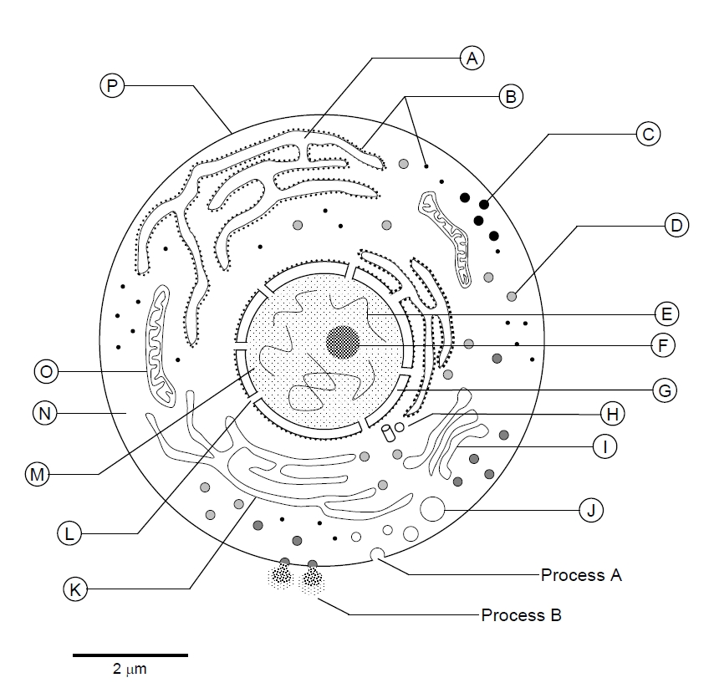

In the space provided, give the function of the following organelles. Use point form. Use your own words. In the space provided make a sketch.
Organelles  And Picture | Function | Plant  Animal  Both
Cell membrane

Nucleus

RER
SER

Golgi Bodies

Lysosomes

Mitochondria

Ribosome

Vesicle

Chromatin (not an organelle)

Nucleolus (not an organelle)

Cells Student Objectives

Enduring understanding 2.A: Growth, reproduction and maintenance of the organization of living systems require free energy and matter.
Essential knowledge 2.A.1: All living systems require constant input of free energy.
a. Life requires a highly ordered system.
Evidence of student learning is a demonstrated understanding of each of the following:
1. Order is maintained by constant free energy input into the system.
2. Loss of order or free energy flow results in death.
3. Increased disorder and entropy are offset by biological processes that maintain or increase order.
b. Living systems do not violate the second law of thermodynamics, which states that entropy increases over time.
Evidence of student learning is a demonstrated understanding of each of the following:
1. Order is maintained by coupling cellular processes that increase entropy (and so have negative changes in free energy) with those thaecrease entropy (and so have positive changes in free energy).
2. Energy input must exceed free energy lost to entropy to maintain order and power cellular processes.
Student Objectives
- Explain how cells are able to remain alive and increase in complexity in accordance with the second law of thermodynamics.
- Compare the strategies employed by different lineages of cells to acquire and utilize free energy.

Learning Objectives:
- The student is able to explain how biological systems use free energy based on empirical data that all organisms require constant energy input to maintain organization, to grow and to reproduce.
- The student is able to justify a scientific claim that free energy is required for living systems to maintain organization, to grow or to reproduce, but that multiple strategies exist in different living systems.

Essential knowledge 2.A.3: Organisms must exchange matter with the environment to grow, reproduce and maintain organization.
a. Molecules and atoms from the environment are necessary to build new molecules.
Evidence of student learning is a demonstrated understanding of each of the following:
1. Carbon moves from the environment to organisms where it is used to build
carbohydrates, proteins, lipids or nucleic acids. Carbon is used in storage
compounds and cell formation in all organisms.
2. Nitrogen moves from the environment to organisms where it is used in building proteins and nucleic acids. Phosphorus moves from the environment to organisms where it is used in nucleic acids and certain lipids.
b. Surface area-to-volume ratios affect a biological system’s ability to obtain necessary resources or eliminate waste products.
Evidence of student learning is a demonstrated understanding of each of the following:
1. As cells increase in volume, the relative surface area decreases and demand for material resources increases; more cellular structures are necessary to adequately exchange materials and energy with the environment. These limitations restrict cell size.
2. The surface area of the plasma membrane must be large enough to adequately exchange materials; smaller cells have a more favorable surface area-to-volume ratio for exchange of materials with the environment.

Student Objectives
- Explain why surface area-to-volume ratios are important in affecting a biological system’s ability to obtain necessary resources or eliminate waste products.
- Explain the physical considerations that determine the upper and lower limits to cell size.
- Explain why smaller cells have a more favorable surface area-to-volume ratio for exchange of materials with the environment.

Learning Objectives:
- The student is able to use calculated surface area-to-volume ratios to predict which cell(s) might eliminate wastes or procure nutrients faster by diffusion.
- Students will be able to explain how cell size and shape affect the overall rate of nutrient intake and the rate of waste elimination.
- The student is able to justify the selection of data regarding the types of molecules that an animal, plant or bacterium will take up as necessary building blocks and excrete as waste products.
- The student is able to represent graphically or model quantitatively the exchange of molecules between an organism and its environment, and the subsequent use of these molecules to build new molecules that facilitate dynamic homeostasis, growth and reproduction.

Enduring understanding 2.B: Growth, reproduction and dynamic homeostasis require that cells create and maintain internal environments that are different from their external environments.

Essential knowledge 2.B.1: Cell membranes are selectively permeable due to their structure.
a. Cell membranes separate the internal environment of the cell from the external environment.
b. Selective permeability is a direct consequence of membrane structure, as described by the fluid mosaic model.
Evidence of student learning is a demonstrated understanding of each of the following:
1. Cell membranes consist of a structural framework of phospholipid molecules, embedded proteins, cholesterol, glycoproteins and glycolipids.
2. Phospholipids give the membrane both hydrophilic and hydrophobic properties. 3. The hydrophilic phosphate portions of the phospholipids are oriented toward the aqueous external or internal environments, while the hydrophobic fatty acid portions face each other within the interior of the membrane itself.
4. Embedded proteins can be hydrophilic, with charged and polar side groups, or hydrophobic, with nonpolar side groups.
5. Small, uncharged polar molecules and small nonpolar molecules, such as N2, freely pass across the membrane. Hydrophilic substances such as large polar molecules and ions move across the membrane through embedded channel and transport proteins. Water moves across membranes and through channel proteins called aquaporins.
c. Cell walls provide a structural boundary, as well as a permeability barrier for some substances to the internal environments.
Evidence of student learning is a demonstrated understanding of each of the following:
1. Plant cell walls are made of cellulose and are external to the cell membrane.
2. Other examples are cells walls of prokaryotes and fungi.

Student Objectives
- Explain the role of the cell membrane?
- How is selective permeability related to the fluid mosaic model.
- Describe the components of the Cell membranes
- What properties do Phospholipids give the membrane?
- Describe the orientation of phospholipids in a cell membrane.
- Describe the chemical characteristics of membrane proteins, and how this effects their position in the membrane.
- Describe the movement of the following through the membrane: Small, uncharged polar molecules, small nonpolar molecules (e.g. N₂), Hydrophilic substances (e.g. large polar molecules and ions), and water.
- Describe the function of the cell walls.
- Describe the composition and location of plant cell walls.
- Describe the composition and location of cells walls of prokaryotes and fungi.

Learning Objectives:
- The student is able to use representations and models to pose scientific questions about the properties of cell membranes and selective permeability based on molecular structure.
- The student is able to construct models that connect the movement of molecules across membranes with membrane structure and function.
Essential knowledge 2.B.2: Growth and dynamic homeostasis are maintained by the constant movement of molecules across membranes.

a. Passive transport does not require the input of metabolic energy; the net movement of molecules is from high concentration to low concentration.
Evidence of student learning is a demonstrated understanding of each of the following:
1. Passive transport plays a primary role in the import of resources and the export of wastes.
2. Membrane proteins play a role in facilitated diffusion of charged and polar molecules through a membrane.
To demonstrate understanding, make sure you can explain examples like:
- Glucose transport
- Na+/K+ transport
3. External environments can be hypotonic, hypertonic or isotonic to internal environments of cells.
b. Active transport requires free energy to move molecules from regions of low concentration to regions of high concentration.
Evidence of student learning is a demonstrated understanding of each of the following:
1. Active transport is a process where free energy (often provided by ATP) is used by proteins embedded in the membrane to “move” molecules and/or ions across the membrane and to establish and maintain concentration gradients.
2. Membrane proteins are necessary for active transport.
c. The processes of endocytosis and exocytosis move large molecules from the external environment to the internal environment and vice versa, respectively.
Evidence of student learning is a demonstrated understanding of each of the following:
1. In exocytosis, internal vesicles fuse with the plasma membrane to secrete large macromolecules out of the cell.
2. In endocytosis, the cell takes in macromolecules and particulate matter by forming new vesicles derived from the plasma membrane.

Student Objectives
- Describe passive transport and explain its role in cellular systems
- Explain how membrane proteins play a role in facilitated diffusion of charged and polar molecules in general and in relation to the specific molecules below.
  - Glucose transport
  - Na+/K+ transport
- Explain the terms: hypotonic, hypertonic or isotonic in relationship to the internal environments of cells.
- Describe active transport.
- Explain the relationship between active transport, free energy and proteins embedded in the membrane.
- Describe the processes of endocytosis and exocytosis.
Learning Objective:
- The student is able to use representations and models to analyze situations or solve problems qualitatively and quantitatively to investigate whether dynamic homeostasis is maintained by the active movement of molecules across membranes.
Essential knowledge 2.B.3: Eukaryotic cells maintain internal membranes that partition the cell into specialized regions.
a. Internal membranes facilitate cellular processes by minimizing competing interactions and by increasing surface area where reactions can occur.
b. Membranes and membrane-bound organelles in eukaryotic cells localize (compartmentalize) intracellular metabolic processes and specific enzymatic reactions. [See also 4.A.2]
To demonstrate understanding, make sure you can explain examples like:
- Endoplasmic reticulum
- Mitochondria
- Chloroplasts
- Golgi
- Nuclear envelope
c. Archaea and Bacteria generally lack internal membranes and organelles and have a cell wall.
Student Objectives:
- Explain how internal membranes facilitate simultaneous occurrence of diverse cellular processes.
- Using the examples from below to explain how membranes and membrane-bound organelles in eukaryotic cells localize (compartmentalize) intracellular metabolic processes and specific enzymatic reactions.
  - Endoplasmic reticulum
  - Mitochondria
  - Chloroplasts
  - Golgi
  - Nuclear envelope
- Why is compartmentalization limited to eukaryotic cells?

Learning Objectives:
- The student is able to explain how internal membranes and organelles contribute to cell functions.
- The student is able to use representations and models to describe differences in prokaryotic and eukaryotic cells.

Enduring understanding 3.D: Cells communicate by generating, transmitting and receiving chemical signals.
Essential knowledge 3.D.1: Cell communication processes share common features that reﬂect a shared evolutionary history.
a. Communication involves transduction of stimulatory or inhibitory signals from other cells, organisms or the environment.
b. Correct and appropriate signal transduction processes are generally under strong selective pressure.
c. In single-celled organisms, signal transduction pathways influence how the cell responds to its environment.
To demonstrate understanding, make sure you can explain examples like:
- Use of chemical messengers by microbes to communicate with other nearby cells and to regulate specific pathways in response to population density (quorum sensing)
- Use of pheromones to trigger reproduction and developmental pathways
- Response to external signals by bacteria that influences cell movement
d. In multicellular organisms, signal transduction pathways coordinate the activities within individual cells that support the function of the organism as a whole.
To demonstrate understanding, make sure you can explain examples like:
- Epinephrine stimulation of glycogen breakdown in mammals

Student Objectives
- List the types of signals involved in communication and where they come from.
- Describe why signal transduction pathways that are under strong selective pressure.
- Use an example to explain how signal transduction pathways influence how the cell responds to its environment in unicellular organisms.
- Using an example to explain how signal transduction pathways coordinate the activities within individual cells that support the function of the organism as a whole in multi-cellular organisms.

Learning Objectives:
- The student is able to describe basic chemical processes for cell communication shared across evolutionary lines of descent.
- The student is able to generate scientific questions involving cell communication as it relates to the process of evolution.
- The student is able to use representation(s) and appropriate models to describe features of a cell signaling pathway.

Essential knowledge 3.D.2: Cells communicate with each other through direct contact with other cells or from a distance via chemical signaling.
a. Cells communicate by cell-to-cell contact.
To demonstrate understanding, make sure you can explain examples like:
- Immune cells interact by cell-cell contact, antigen-presenting cells (APCs), helper T-cells and killer T-cells.
- Plasmodesmata between plant cells that allow material to be transported from cell to cell.
b. Cells communicate over short distances by using local regulators that target cells in the vicinity of the emitting cell.
To demonstrate understanding, make sure you can explain examples like:
- Neurotransmitters
- Plant immune response
- Quorum sensing in bacteria
- Morphogens in embryonic development
c. Signals released by one cell type can travel long distances to target cells of another cell type.
Student Objectives:
- Use an example to explain how cells communicate by cell-to-cell contact.
- Use an example to explain how cells communicate over short distances by using local regulators that target cells in the vicinity of the emitting cell.
- Explain how signals released by one cell type can travel long distances to target cells of another cell type.
Learning Objectives:
- The student is able to construct explanations of cell communication through cell-to-cell direct contact or through chemical signaling.
- The student is able to create representation(s) that depict how cell-to-cell communication occurs by direct contact or from a distance through chemical signaling.

Essential knowledge 3.D.3: Signal transduction pathways link signal reception with cellular response.
a. Signaling begins with the recognition of a chemical messenger, a ligand, by a receptor protein.
Evidence of student learning is a demonstrated understanding of each of the following:
1. Different receptors recognize different chemical messengers, which can be peptides, small chemicals or proteins, in a specific one-to-one relationship.
2. A receptor protein recognizes signal molecules, causing the receptor protein’s shape to change, which initiates transduction of the signal.
To demonstrate understanding, make sure you can explain examples like:
- G-protein linked receptors
- Ligand-gated ion channels
- Receptor tyrosine kinases
b. Signal transduction is the process by which a signal is converted to a cellular response.
Evidence of student learning is a demonstrated understanding of each of the following:
1. Signaling cascades relay signals from receptors to cell targets, often amplifying the incoming signals, with the result of appropriate responses by the cell.
2. Second messengers are often essential to the function of the cascade.
To demonstrate understanding, make sure you can explain examples like:
- Ligand-gated ion channels
- Second messengers, such as cyclic GMP, cyclic AMP calcium ions (Ca²⁺), and inositol triphosphate (IP3)
3. Many signal transduction pathways include:
i. Protein modifications (an illustrative example could be how methylation changes the signaling process)
ii. Phosphorylation cascades in which a series of protein kinases add a phosphate group to the next protein in the cascade sequence

Student Objectives:
- Describe how signals are received by cells.
- List the types of different chemical messengers and explain the specific one-to-one relationship with their receptors.
- Using an example to explain how a receptor protein recognizes signal molecules, causing the receptor protein’s shape to change, which initiates transduction of the signal.
- Describe the process of signal transduction.
- Explain the concept of signaling cascades.
- Use an example to explain how second messengers are often essential to the function of a signaling cascade.
- Explain the effects of protein modifications on the signaling cascade
- Explain the effects of phosphorylation on the signaling cascade.

Learning Objectives:
- The student is able to describe a model that expresses the key elements of signal transduction pathways by which a signal is converted to a cellular response.

